# Algorithm for file updates in Python

## Project description

## As a cybersecurity analyst at a health care company, I am responsible for controlling employee access to a restricted subnetwork that holds personal patient data. Access is granted based on IP addresses listed in a file named allow_list.txt. I created a Python algorithm to update this file by removing IP addresses that appear on a separate remove_list. This process ensures only authorized users can connect to sensitive systems, reducing security risks.

## Open the file that contains the allow list

The with statement automatically handles closing the file after the code block executes. The open() function is used with the "r" mode to read the contents of the file.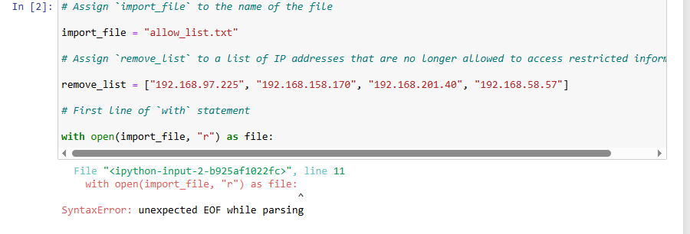

## Read the file contents

This string stores all IP addresses as one block of text, which we will later convert into a list to allow filtering and modification.

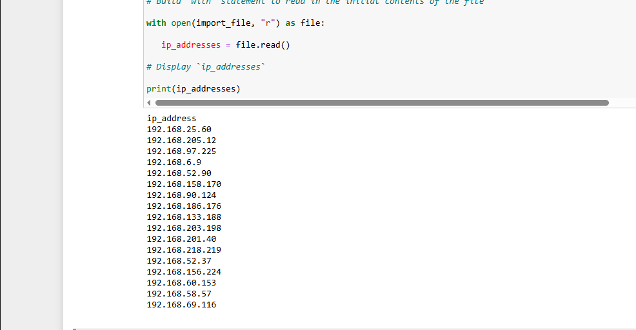

## Convert the string into a list

The .split() method divides the string into a list of IP addresses, separated by whitespace (typically newline characters).

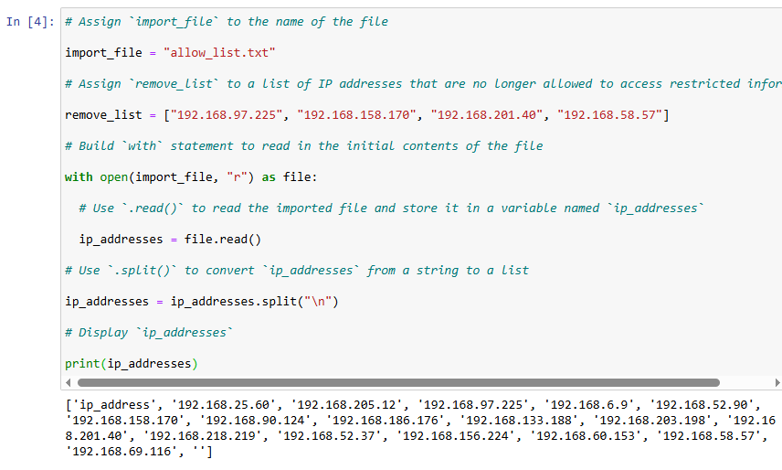

## Iterate through the remove list

This loop visits each IP address in the remove_list one at a time.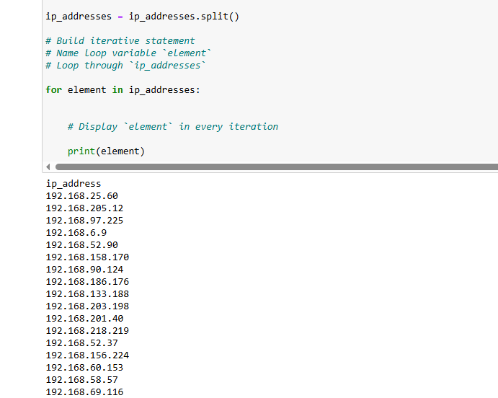

## Remove IP addresses that are on the remove list

This method works as expected here because the IP addresses are unique, there are no duplicates in the list.

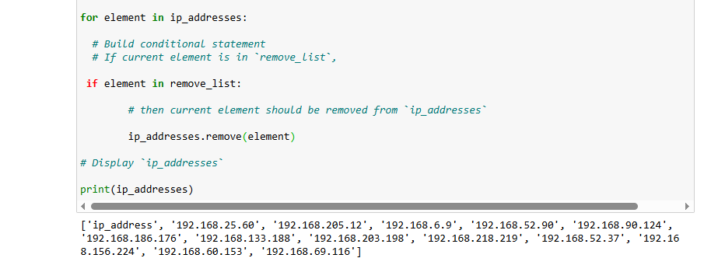

## Update the file with the revised list of IP addresses

.join() combines the list into a formatted string.

with open(import_file, "w") opens the file in write mode.

.write() replaces the file content with the updated IP addresses.

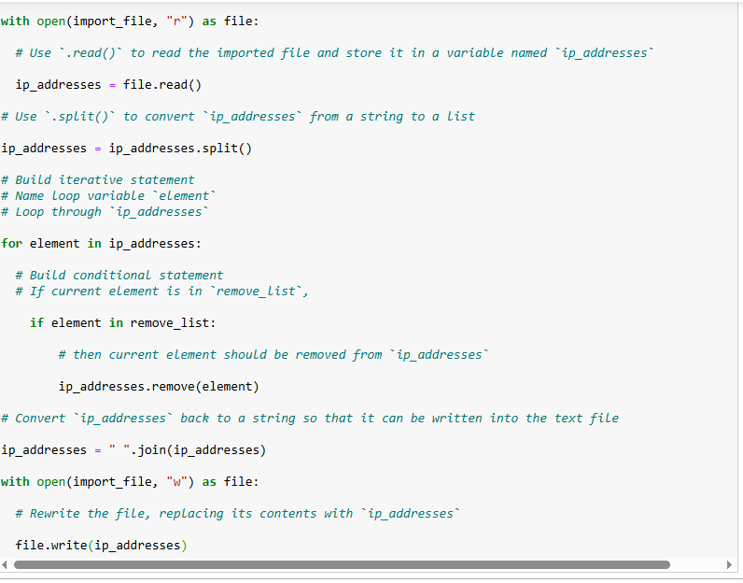

## Summary

This Python algorithm automates the process of maintaining access control based on IP addresses in a healthcare organization. The script opens a file, reads its contents, splits the data into a list, removes unauthorized entries based on a second list and writes the revised list back to the file. Key features of the algorithm include the use of the with statement for safe file handling, string to list conversion with .split(), and list modification using .remove(). The final result is a secure, accurate list of IPs with access to sensitive systems.